SIMATS ENGINEERING (SAVEETHA SCHOOL OF ENGINEERING)
Department of Computer Science and Engineering
CO1 ASSESSMENT TOOL 2 – Agile Sprint Planning & User Story Workshop

Course Code: | CSA10 / CSA1063 | Course Title: | Software Engineering
CO Assessed: | CO1 | Assessment: | Assessment Tool 2 – Agile Sprint Planning & User Story Workshop
Weightage: | 20% | Total Marks: | 25
CO1 Statement: | Apply advanced methodologies and agile project management techniques to manage software projects effectively
Student Name: | Dhanushree S | Reg. No.: | 192421218
Date: | 27/07/2026 | Duration: | 60 minutes

Code of Conduct
I Dhanushree S-192421218 (Name / Reg No) certify that this submission is my original work and that I have adhered to the guidelines specified for this assessment. I understand that any violation of academic integrity rules will result in disciplinary action.
Signature of the Student: Dhanushree S

Annexure A – Agile Sprint Planning & User Story Workshop

AI-Based Crop Disease Detection and Farmer Advisory Platform

\
1. Project Vision and Stakeholders
Project Vision
The AI-Based Crop Disease Detection and Farmer Advisory Platform is an intelligent software solution designed to assist farmers in identifying crop diseases at an early stage using Artificial Intelligence (AI), Machine Learning (ML), and Computer Vision. Farmers can upload images of infected crops through a mobile or web application, and the AI model analyzes the image to detect diseases with high accuracy. Based on the detected disease, the platform provides personalized treatment recommendations, fertilizer suggestions, pesticide guidance, weather-based advisories, and preventive farming practices. The platform aims to improve agricultural productivity, reduce crop losses, minimize excessive pesticide usage, and promote sustainable farming through digital technology.
Project Objectives
- Develop an AI-powered crop disease detection platform.
- Detect diseases using image processing and deep learning models.
- Provide accurate disease diagnosis with confidence scores.
- Recommend suitable pesticides, fertilizers, and organic treatments.
- Deliver weather-based farming advisories.
- Maintain crop disease history for future reference.
- Enable agricultural experts to update disease recommendations.
- Provide multilingual support for farmers.
- Reduce crop losses through early disease detection.
- Improve overall agricultural productivity and sustainability.

Key Stakeholders
Stakeholder | Role | Responsibilities
Farmer | Primary User | Upload crop images, receive disease diagnosis and farming advice
Agricultural Expert | Domain Expert | Validate AI predictions and update recommendations
Administrator | System Administrator | Manage users, AI models, reports, and system security
AI Prediction Engine | Intelligent System | Detect crop diseases using AI algorithms
Government Agriculture Department | External Stakeholder | Provide farming schemes and agricultural policies
Researchers | Data Analysts | Improve AI model performance
Development Team | Software Developers | Design, develop, test, and deploy the system
Product Owner | Product Manager | Prioritize product backlog
Scrum Master | Agile Facilitator | Manage Agile sprint planning and Scrum meetings

2. Create Epics and User Stories
Epic 1: User Registration and Authentication
User Story 1
As a farmer, I want to register an account so that I can use the crop disease detection platform.
User Story 2
As a farmer, I want to log in securely so that my farming data remains protected.
User Story 3
As a farmer, I want to update my profile so that the system provides personalized recommendations.

Epic 2: Crop Disease Detection
User Story 4
As a farmer, I want to upload crop images so that AI can detect diseases accurately.
User Story 5
As a farmer, I want to capture crop images using my mobile camera so that I can quickly diagnose diseases.
User Story 6
As a farmer, I want to receive disease prediction results so that I know what disease affects my crop.

Epic 3: Farmer Advisory
User Story 7
As a farmer, I want treatment recommendations so that I can cure infected crops.
User Story 8
As a farmer, I want fertilizer recommendations so that I can improve crop health.
User Story 9
As a farmer, I want pesticide recommendations so that I can control crop diseases safely.
User Story 10
As a farmer, I want weather-based farming advice so that I can plan agricultural activities effectively.

Epic 4: Crop History
User Story 11
As a farmer, I want to view previous disease records so that I can monitor crop health over time.
User Story 12
As a farmer, I want to download disease reports so that I can share them with agricultural experts.

Epic 5: Expert Management
User Story 13
As an agricultural expert, I want to review AI predictions so that I can improve disease diagnosis accuracy.
User Story 14
As an agricultural expert, I want to update treatment recommendations so that farmers receive accurate guidance.

Epic 6: Administration
User Story 15
As an administrator, I want to manage users so that unauthorized access is prevented.
User Story 16
As an administrator, I want to monitor AI prediction performance so that the platform remains reliable.
User Story 17
As an administrator, I want to generate reports so that overall system performance can be evaluated.

3. Acceptance Criteria (Given–When–Then)
User Story 1 – Farmer Registration
Given the farmer is on the registration page
When valid personal details are entered
Then the account should be created successfully.

User Story 4 – Upload Crop Image
Given the farmer selects a crop image
When the upload button is clicked
Then the image should be uploaded successfully.

User Story 6 – Disease Detection
Given the uploaded image is analyzed
When AI completes prediction
Then the detected disease name, confidence score, and affected crop should be displayed.

User Story 7 – Treatment Recommendation
Given the disease has been detected
When the farmer views the diagnosis
Then suitable treatment methods should be displayed.

User Story 10 – Weather Advisory
Given weather information is available
When the farmer opens the advisory page
Then weather forecasts and farming suggestions should appear.

User Story 13 – Expert Review
Given AI prediction is available
When the agricultural expert reviews it
Then the expert can modify treatment recommendations.

User Story 15 – User Management
Given the administrator logs into the dashboard
When user records are viewed
Then the administrator should be able to add, edit, or remove users.

4. Product Backlog Prioritization
Priority | Product Backlog Item | Business Value | Dependency
High | Farmer Registration | Essential | None
High | Login Module | Essential | Registration
High | Crop Image Upload | Critical | Login
High | AI Disease Detection | Critical | Image Upload
High | Disease Prediction | Critical | AI Detection
High | Treatment Recommendation | Critical | Disease Prediction
High | Weather Advisory | High | API Integration
Medium | Fertilizer Recommendation | Medium | Disease Prediction
Medium | Pesticide Recommendation | Medium | Disease Prediction
Medium | Disease History | Medium | Database
Medium | Report Generation | Medium | Database
Low | Notifications | Low | Login
Low | Multilingual Support | Low | UI Development
Low | Government Scheme Updates | Low | Admin Module

5. Sprint Backlog (Sprint 1 – Two Weeks)
User Story | Development Tasks | Assigned To
Registration | Design Registration UI | Frontend Developer
Registration | Database Integration | Backend Developer
Login | Authentication Module | Backend Developer
Upload Image | Develop Image Upload Screen | Frontend Developer
Upload Image | Image Storage API | Backend Developer
AI Detection | Integrate AI Model | AI Engineer
Disease Prediction | Display Results | Full Stack Developer
Advisory Module | Treatment Recommendation Page | Backend Developer
Weather Advisory | Integrate Weather API | Backend Developer
Testing | Unit & Integration Testing | QA Engineer

6. Story Point Estimation (Fibonacci Technique)
User Story | Story Points | Justification
Registration | 3 | Simple UI and validation
Login | 3 | User authentication
Upload Image | 5 | Image processing
AI Disease Detection | 13 | Deep learning integration
Disease Prediction | 8 | AI result processing
Treatment Recommendation | 5 | Database retrieval
Weather Advisory | 8 | External API integration
Disease History | 5 | Database operations
Admin Dashboard | 8 | Multiple management functions
Report Generation | 5 | Report creation and export
Fibonacci Sequence Used
1, 2, 3, 5, 8, 13, 21
Justification
- 1–3 Points: Simple tasks with low complexity.
- 5 Points: Medium-complexity development tasks.
- 8 Points: Complex features requiring multiple components.
- 13 Points: AI model integration and advanced processing.
- 21 Points: Reserved for large-scale future enhancements.

7. Sprint Goal and Expected Deliverables
Sprint Goal
The objective of Sprint 1 is to develop a functional prototype of the AI-Based Crop Disease Detection and Farmer Advisory Platform. By the end of the sprint, farmers should be able to register, log in, upload crop images, receive AI-based disease predictions, and view treatment recommendations. The sprint also focuses on building the core application architecture and integrating the AI prediction model.

Expected Sprint Deliverables
- Farmer Registration Module
- Secure Login and Authentication
- Farmer Profile Management
- Crop Image Upload Module
- AI Disease Detection Engine
- Disease Prediction with Confidence Score
- Treatment Recommendation Module
- Fertilizer Recommendation Module
- Weather Advisory Integration
- Admin Dashboard
- Database Design
- REST API Development
- AI Model Integration
- Unit Testing
- Integration Testing
- Sprint Review Report
- Sprint Retrospective Report
Conclusion
The AI-Based Crop Disease Detection and Farmer Advisory Platform demonstrates how Agile software engineering practices can be effectively applied to develop an intelligent agricultural solution. Through Agile Sprint Planning, the project is divided into manageable iterations, allowing the development team to continuously deliver valuable features such as AI-powered disease detection, treatment recommendations, weather-based advisories, and expert guidance. The use of epics, user stories, acceptance criteria, product backlog prioritization, sprint backlog planning, and Fibonacci story point estimation ensures efficient project management, stakeholder collaboration, and timely software delivery. Ultimately, the platform empowers farmers with advanced technology, helping them improve crop health, reduce agricultural losses, increase productivity, and promote sustainable farming practices. This structured Agile approach ensures high-quality software development while adapting to changing user requirements throughout the project lifecycle

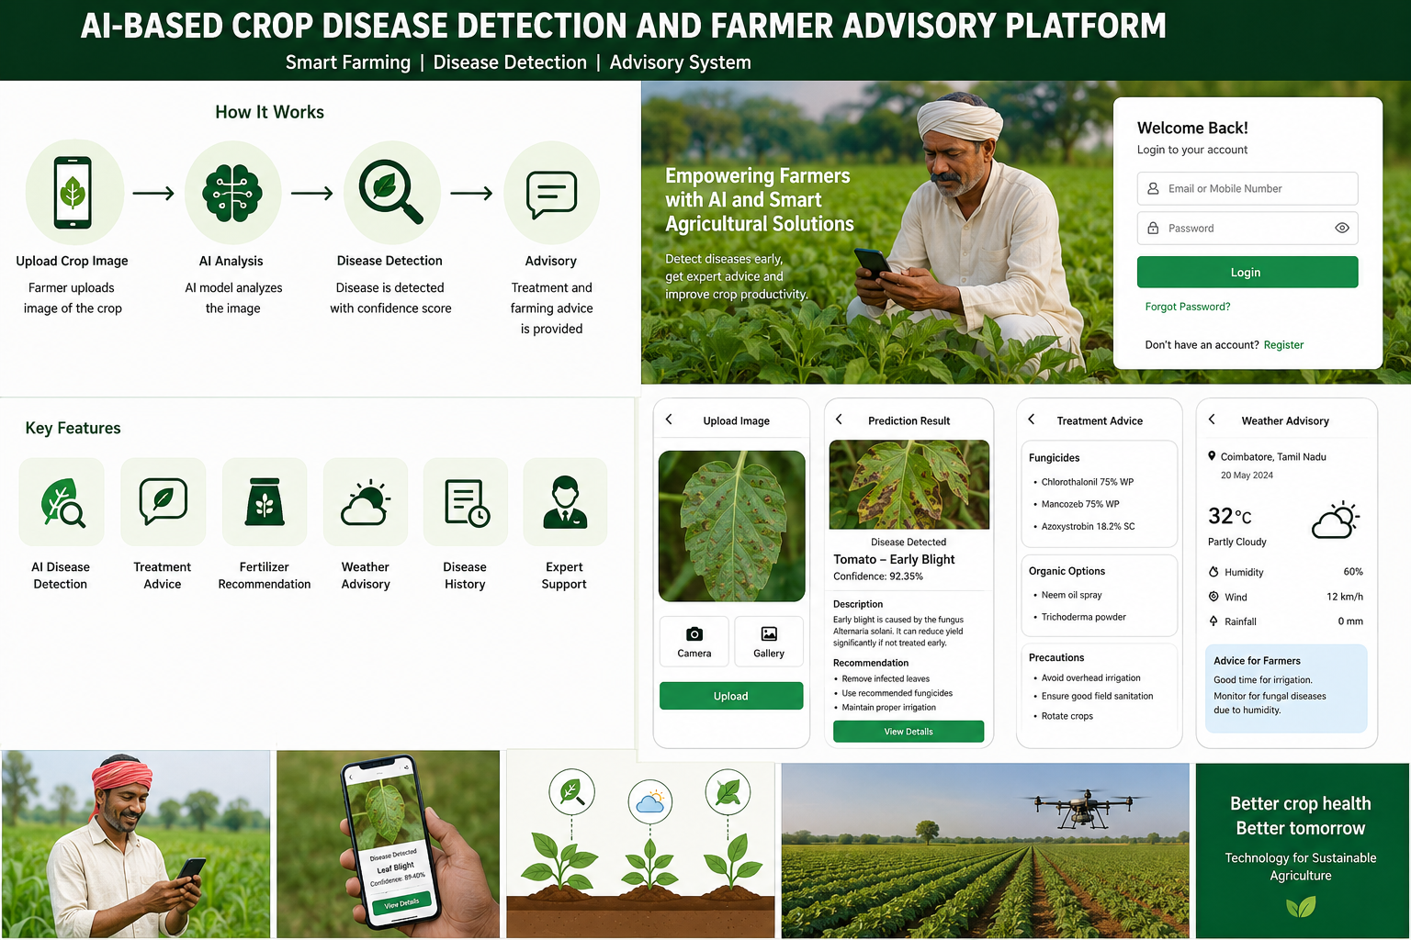

Rubrics for Calculation
Criteria | Excellent (5 Marks) | Good (3 Marks) | Satisfactory (2 Marks) | Needs Improvement (1 Mark)
Project Vision & Stakeholder Identification | Project vision is clear, comprehensive, and aligned with the problem statement. All relevant stakeholders and their roles are correctly identified. | Vision is clear with minor omissions. Most stakeholders are correctly identified. | Vision is partially defined. Some stakeholders are missing or incorrectly identified. | Vision is unclear or incomplete. Stakeholders are poorly identified or missing.
Epics & User Stories | Epics are well-defined and user stories are complete, follow Agile format, and fully capture functional requirements. | Epics and user stories are mostly complete with minor formatting or requirement issues. | User stories are partially complete with limited Agile structure. | User stories are incomplete, unclear, or do not follow Agile practices.
Acceptance Criteria | Acceptance criteria are specific, measurable, testable, and aligned with all user stories. | Acceptance criteria are mostly clear and testable with minor gaps. | Acceptance criteria are partially defined and lack clarity or completeness. | Acceptance criteria are missing or not aligned with user stories.
Product Backlog Prioritization & Sprint Planning | Product backlog is logically prioritized, sprint backlog is realistic, and task breakdown is complete. | Backlog prioritization and sprint planning are mostly appropriate with minor issues. | Prioritization or sprint planning is partially complete with limited justification. | Backlog prioritization and sprint planning are poorly organized or incomplete.
Story Point Estimation, Sprint Goal & Presentation | Story point estimation is well justified, sprint goal is clear, deliverables are realistic, and presentation is professional and well organized. | Estimation and sprint goal are mostly appropriate with minor inconsistencies. Presentation is clear. | Estimation or sprint goal lacks justification. Presentation is adequate but incomplete. | Estimation is unrealistic or missing. Sprint goal, deliverables, and presentation are unclear or incomplete.

Criteria | Mark
Project Vision & Stakeholder Identification | /5
Epics & User Stories | /5
Acceptance Criteria | /5
Product Backlog Prioritization & Sprint Planning | /5
Story Point Estimation, Sprint Goal & Presentation | /5
TOTAL | /25

